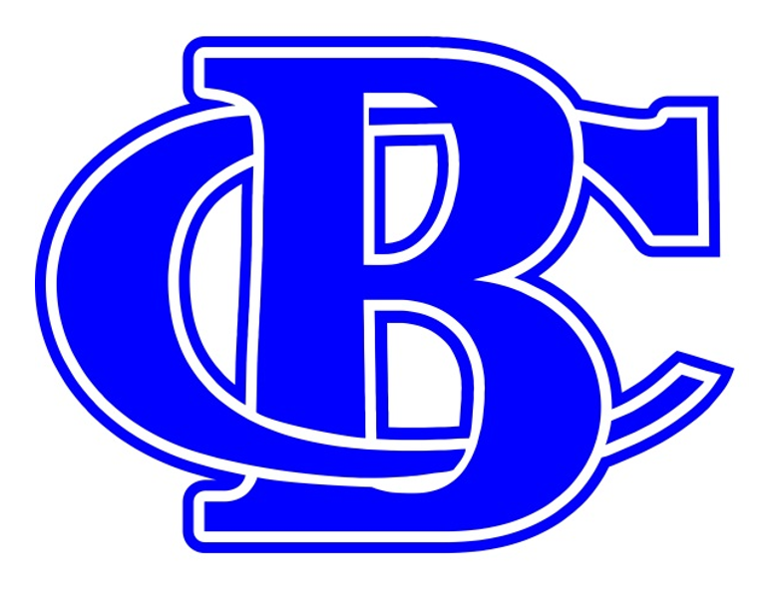
Banks County Football
2019 Ad/Program Form
Banks County Touchdown Club

Contact INFORMATION
Company Name |  | Email
Contact Person |  | Address

Phone

Order INFORMATION
Packages with 4’x8’ Sign | Packages without Sign | Payment Method
◻ Gold Leopard - $1000 | ◻ Blue Leopard - $500 | ◻ Cash
◻ Silver Leopard - $800 | ◻ White Leopard - $400 | ◻ Check #__________ | ◻ Receipt Request
◻ Bronze Leopard - $700 | ◻ Gray Leopard - $300 | ◻ Other _______________________________________________
*Package breakdown on back. |  | *Checks payable to Banks County TD Club

Ad Information
Media | Special Instructions
◻ I am sending artwork | ___________________________________________________________________  ___________________________________________________________________  ___________________________________________________________________  ___________________________________________________________________
◻ Crump Photo will take my photo
◻ Use last year’s artwork
◻ I’ll email my artwork to: bcleopardfootball@gmail.com

additional options
Season Tickets/Reserved Parking |  | Sign Only | Ad Only
◻ 1 Seat- $75.00 | ◻ 4 Seats- $150.00 | ◻ New 4’x8’ Sign- $500 | ◻ Full Page Ad- $200
◻ 2 Seats- $100.00 | ◻ 5 Seats- $175.00 | ◻ Renew Existing Sign- $300 | ◻ Half Page Ad- $150
◻ 3 Seats- $125.00 | ◻ 6 Seats- $200.00 |  | ◻ Quarter Page Ad- $100
 |  | Jumbotron Advertisement
 |  | ◻ Digital/Jumbotron Ad - $250

ADS MUST BE PAID FOR AND SUBMITTED BY
JULY 1, 2019

PLEASE REMIT PAYMENT / FORM / ARTWORK TO
Banks County TD Club | james.reid@banks.k12.ga.us | P.O. Box 4 | Homer, GA 30547

AUTHORIZED SIGNATURE ______________________________________________________________________ DATE ____________________________

Thank you for your continued support of Banks County Football!

Sponsor Packages
Sponsor Packages with Sign | Sponsor Packages without Sign
Gold Leopard Sponsor ($1000) | Blue Leopard Sponsor ($500)
(1) 4’x8’ Sign | (4) Season Passes and Access to Reserved Seating/Stadium Seats
(4) Season Passes and Access to Reserved Seating/Stadium Seats | (1) Reserved Season Parking
(1) Reserved Season Parking | (1) Full Page Ad in Fall Program
(1) Full Page Ad in Fall Program
Silver Leopard Sponsor ($800) | White Leopard Sponsor ($400)
(1) 4’x8’ Sign | (2) Season Passes and Access to Reserved Seating/Stadium Seats
(2) Season Passes and Access to Reserved Seating/Stadium Seats | (1) Reserved Season Parking
(1) Reserved Season Parking | (1) Half Page Ad in Fall Program
(1) Half Page Ad in Fall Program
Bronze Leopard Sponsor ($700) | Gray Leopard Sponsor ($300)
(1) 4’x8’ Sign | (2) Season Passes and Access to Reserved Seating/Stadium Seats
(2) Season Passes and Access to Reserved Seating/Stadium Seats | (1) Reserved Season Parking
(1) Reserved Season Parking | (1) Quarter Page Ad in Fall Program
(1) Quarter Page Ad in Fall Program

